Fun and Culture Camp Registration
7th Generation Program

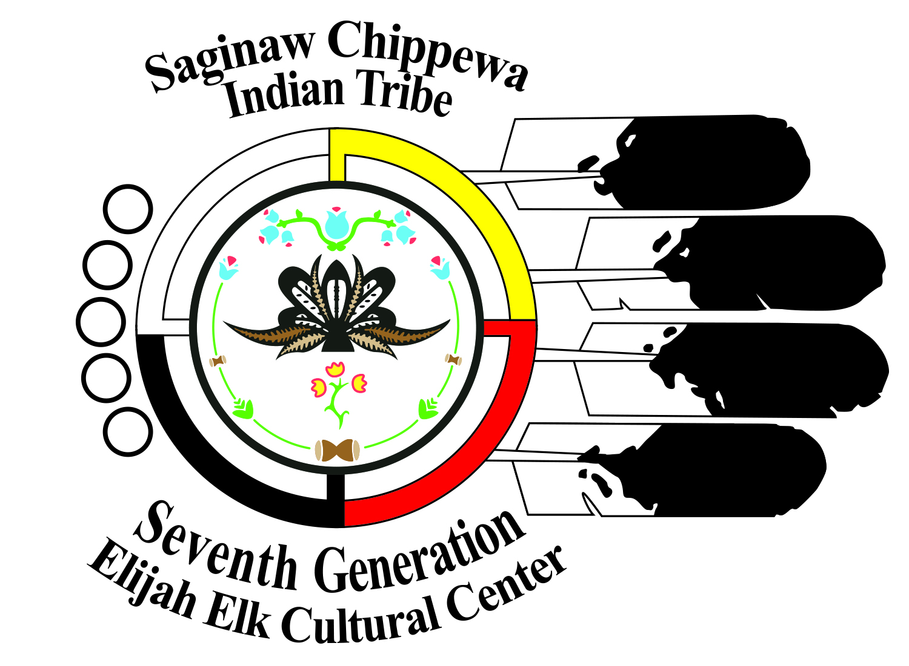

Participant’s Name_______________________________
Address________________________________________
Parent/Guardian Name_____________________________
Work#_______________ cell#___________________
Email_____________________
Emergency Contact________________________________
Emergency Contact #______________________________
Allergies: ______________________________________
Accident waiver and release of liability form
I hereby assume all of the risks of participating in any/all activities associated with the Saginaw Chippewa Indian Tribe (SCIT) and the fun and culture camp including by way of example and not limitation, any risks that may arise from greater than ordinary negligence or carelessness on the part of the persons or entities being released, from dangerous or defective equipment or property owned, maintained, or controlled by them, or because of their possible liability without fault.
I certify that there are no health related reasons or problems which preclude my participation in this activity.
I acknowledge that this Accident waiver and release of liability form will be used by the event holders, sponsors, and organizers of the activity in which I may participate, and that it will govern my actions and responsibilities at said activity.
In consideration of my application and permitting me to participate in this activity, I hereby take action for myself, my executors, administrators, heirs, next of kin, successors, and assigns as follows;
(A)I WAIVE, RELEASE, AND DISCHARGE from any and all liability, including but not limited to, liability arising from the greater than ordinary negligence or fault the entities or persons released, for my death, disability, personal injury, property damage, property theft, or actions of any kind which may hereafter occur to Saginaw Chippewa Indian Tribe and/or their directors, officers, employees, volunteers, representatives, and agents, and the activity holders, sponsors, and volunteers;
(B)INDEMNIFY, HOLD HARMLESS, AND PROMISE NOT TO SUE the entities or persons mentions in this paragraph from any and all liabilities or claims made as a result of participation in this activity, whether caused by the negligence of release or otherwise.

I acknowledge that 7th Generation and their directors, officers, volunteers, representatives, and agents are NOT responsible for the errors, omissions, acts, or failures to act of any party or entity conducting a specific activity on their behalf.
The Accident Waiver and Release of Liability Form shall be construed broadly to provide a release and waiver to the maximum extent permissible under applicable law.

I CERIFY THAT I HAVE RED THIS DOCUMENT AND I FULLY UNDERSTAND ITS CONTENT. I AM AWARE THAT THIS IS A RELEAS OF LIABLILTY AND A CONTRACT AND I SIGN IT OF MY OWN FREE WILL.

________________________________ _______________
Participant Name Date

________________________________ _______________
Parent/Guardian Signature Date

